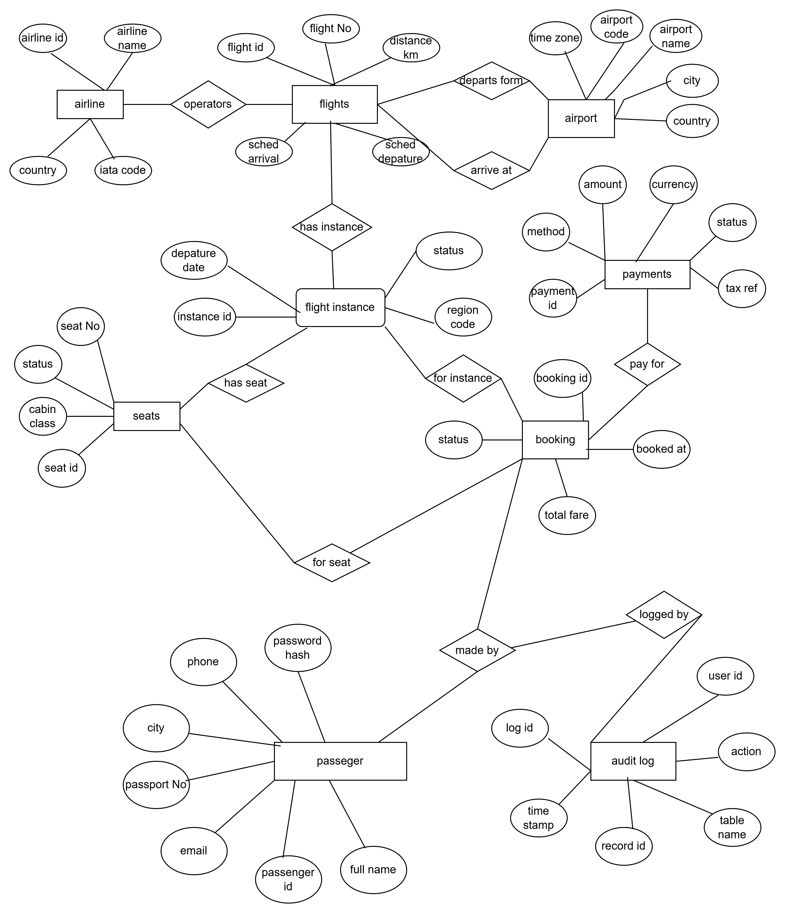

Tracks earned and redeemed frequent flyer miles per passenger per booking. Linked to both passengers and bookings to enable point-in-time auditing of miles balance.

3.1 Notation ER-Diagram for Flight Booking System
The ER Diagram uses Chen notation (crow's foot for cardinality): rectangles represent entities, ellipses represent attributes, diamonds represent relationships, underlined attributes indicate primary keys, and (FK) indicates foreign keys. Cardinalities shown are 1 (one) and N (many).

3.2 Relational Schema
airlines (airline_id INT PK, airline_name VARCHAR(100), iata_code CHAR(2), country VARCHAR(80))
airports (airport_code CHAR(3) PK, airport_name VARCHAR(100), city VARCHAR(80), country VARCHAR(80), timezone VARCHAR(50))
flights (flight_id INT PK, flight_number VARCHAR(10), airline_id INT FK, departure_airport CHAR(3) FK, arrival_airport CHAR(3) FK, scheduled_departure TIME, scheduled_arrival TIME, distance_km INT)
flight_instances (instance_id BIGINT PK, flight_id INT FK, departure_date DATE, status ENUM, region_code TINYINT)
seats (seat_id BIGINT PK, instance_id BIGINT FK, seat_number VARCHAR(4), cabin_class ENUM, status ENUM)
passengers (passenger_id BIGINT PK, full_name VARCHAR(120), email VARCHAR(150) UNIQUE, phone VARCHAR(20), city VARCHAR(80), passport_number VARCHAR(50) UNIQUE, password_hash CHAR(64))
bookings (booking_id BIGINT PK, passenger_id BIGINT FK, instance_id BIGINT FK, seat_id BIGINT FK UNIQUE, status ENUM, booked_at TIMESTAMP, total_fare DECIMAL(10,2))
payments (payment_id BIGINT PK, booking_id BIGINT FK, method ENUM, amount DECIMAL(10,2), currency CHAR(3), status ENUM, paid_at TIMESTAMP, txn_ref VARCHAR(100) UNIQUE)
loyalty_miles (miles_id BIGINT PK, passenger_id BIGINT FK, booking_id BIGINT FK, miles_earned INT, miles_redeemed INT, balance INT)
audit_log (log_id BIGINT PK, table_name VARCHAR(50), record_id BIGINT, action ENUM, performed_by VARCHAR(80), details TEXT, logged_at TIMESTAMP)

